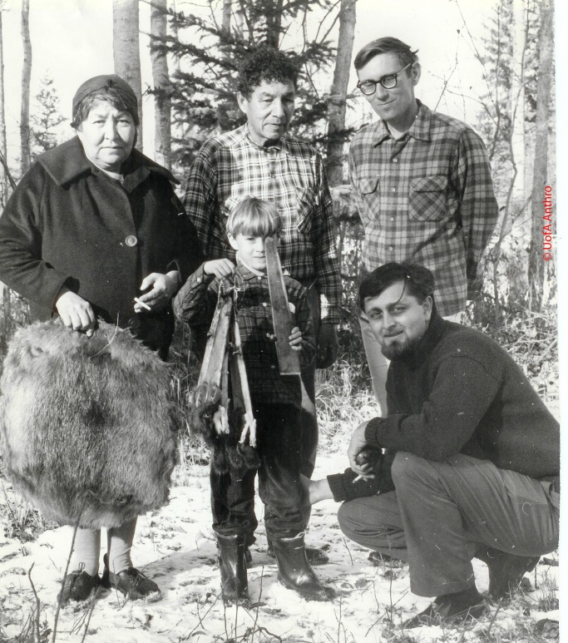
Bo Emery recalls boyhood days
at Calling Lake
It has been more than 50 years since Bo Emery first visited Calling Lake with his father, anthropologist George Emery. Between the ages of 7 and 11, Bo lived for months at a time with Cleophus and Mary Rose Cardinal, soaking up the sights and smells of life in the northern bush.
Bo fondly recalls traipsing traplines as Cleophus harvested and dressed game with skill and respect. Being aboard the boat when Cleophus used a bark cone to attract a moose, then floated the downed moose home across the lake to hang, skin and gut. Watching flotillas of mating loons sashay up and down the lake. Snagging and skinning a weasel that had taken up residence in the family smoke house. Wondering about the farmer who warmed his fields with flares fueled by on-site natural gas. Watching a cart being pulled by a moose down mainstreet, then little more than a path. Playing a game of flip the antlers with the local lads. “Experiences like that never go away;
they leave a lifelong impression,” he says.
Bo Emery in 1967, surrounded (from left) by Mary Rose, Cleophus, Bruce Cox, George Emery and his father, George Emery (U of A photo 40045)
“People who are close to the land recognize when a place is special. Not just because there’s water there or it’s a beautiful place to camp. It’s something more spiritual.
And Calling Lake is one of those places.
I’m certain of that.”
– Bo Emery

Now living in Regina, Saskatchewan, Bo yearns to visit again. He would carry with him the pelt of a squirrel Cleophus gave him when the older man turned 70 and Bo was about to turn 7 – an animal the lad had caught and tanned with his host’s help. “I still have that squirrel,” Bo says. “I would like to find a young Cardinal – some very young man – and give it to him, so he has something touched by his
great great-great-grandfather. It belongs in that community.”
Add to the story
- We are on the prowl for the toy made of antlers and leather string that Bo played with as a boy. If you have such a toy or know someone who does, we would love a photo.
- We are gathering stories and information about the long-ago history of Calling Lake, including the archeological digs and studies done by George Emery and others. Do you or someone you know have stories or artifacts?
To share photos and information, please email cheryl@wordsthatsing.com or call 780-479-3524

