Summary of research published by archaeologist Dr. Ruth Gruhn based on excavations at Calling Lake

Title: Archaeological Research at Calling Lake, Northern Alberta
Archaeological Survey of Canada Paper No. 99
Series: National Museum of Man Mercury Series
Author: Dr. Ruth Gruhn
Published: National Museums of Canada, Ottawa, 1981
Copyright: Crown Copyright Reserved
ISSN: 0316-1854

Overview
An archaeological survey of Calling Lake led by Dr. Ruth Gruhn of the University of Alberta unearthed “an abundance of prehistoric material” whose styles suggest human occupation as far back as 3000 BC. Her team excavated four prehistoric campsites on the east and southeast shore between 1966 and 1968, turning up microblades, projectile points, bifaces, scrapers and heavy tools. Most objects could be linked with cultures of the northern boreal forest, although projectile point styles suggest affiliations with Plains traditions in the south.
Dr. Gruhn’s interest in Calling Lake as a place to explore earlier Boreal Forest cultures was sparked by a report by Fred Broadbent, a member of the Archaeological Society of Alberta, on materials found east of his summer cabin on the east shore of the lake. A preliminary survey by Drs. Gruhn and Alan Bryan in 1965 recorded several other sites, and seven have now been identified, most near the mouth of small streams or on sand ridges.
Anthropological study was also initiated at this time: see Zierhut 1967, Darnell 1971.
Study participants
- Excavation: Ken Arnold, Neva Deemer, Maurice Doll, Vaughan Driscoll, Helen Habgood, Thelma Habgood, Kensaku Hayashi, Sherman Hsu, Isobel Hurlbert, Janis Kostash, Andrée Louis, Lynn Lunde, Ross MacPhee, John Peck, Glenn Snelgrove, Ross Thomson, Norman Zierhut.
- Camp cooks: Elaine Hennig and Bernice Bomersback
- Laboratory analyses: Owen Beattie, Richard Will, Wayne Roberts, Douglas Schnurrenberger, Anna Sawicki
Description of Calling Lake and environs
Calling Lake: Located about 225 km due north of Edmonton, Alberta (approximate Lat. 55◦ 15’ N and Long. 113◦ 15’ W). Roughly elliptical, about 11 km in diameter, about 640 metres above mean sea level. Maximum known depth about 27 metres; old beach ridges in the southeast sector, coupled with excavations on the east shore, suggest the lake level has dropped several metres over time. Several small streams drain into the west and southwest side of the lake; the major inlet stream, unnamed, enters from the north at the northwest corner. The outlet, Calling River, flows from the southeast corner and meanders to the Athabasca River, about 25 km to the east. (p 1)
Terrain: As is common in northern Alberta’s boreal forest zone, the lake is surrounded by many smaller lakes and poorly drained muskeg – a heritage of glaciation, which likely receded by 9000 BC. (1) The lake is in the mixed wood section of the boreal forest, with aspen poplar, white spruce and some birch around the lake and black spruce in the muskeg. (p 2)
Fish: walleye, jackfish or pike, whitefish, suckers, burbot. Commercial fish harvest in mid 1960s of 500,000 pounds, about 90% whitefish. (p 2)
Climate: Long cold winter, short summer. Lake freezes by mid-December; ice breaks up (with considerable noise, hence the name Calling Lake) by mid-May. (p 1)
Settlement: Now heavily concentrated on east and southeast shores. West shore is uncleared and unoccupied. Native population of several hundred, Cree-speaking, is concentrated in the north, in and around the tiny Jean Baptiste Gambler I.R. 183 reserve. Homes of native families are also scattered to the north of the reserve and along the south bank of Calling River. Summer population is increasing as new cabins/cottages are built near the all-weather road from Athabasca. Only a few non-native families are permanent residents. (p 2)
The four excavated sites
The Broadbent site: A fairly level bench about three metres above present lake level and 50 metres south of Two Mile Creek, on provincially managed Crown land and next to a cabin maintained by Fish and Game Division. The only site where significant fish and animal bone fragments were found, some likely macerated to extract marrow and bone grease. Much evidence of flaking to create tools. Artifacts include an incised antler shaft, stone projectile points, bifaces, scrapers, choppers, adze blades, anvil stone, hammerstones. (pp 4-23)
The Sutton site: On property of long-time resident Kenneth Sutton (SE ¼ Sec. 8, Ts. 72, R 21, W4), who found flakes and artifacts in his gardens and when excavating a root cellar and showed them to Bryan and Gruhn in 1964. Disturbed by plowing and modern refuse pits. Similar findings to other sites. (pp 24-42)
Site GhPh106: A about 5 km south of Sutton site, at the southeast corner of the lake, about 100 metres east of the present lake shore. Elevation 644 metres on a low sandy ridge, on the south edge of a low area that appears to be a former cove or inlet. Flakes and fire-cracked rocks were exposed in 1966 by extensive bulldozer cut east of the area. Similar findings to above site, although more stratified. (pp 43-57)
Site GhPh107: About 1 km south of GhPh106 in the southeast part of NW ¼, Sec. 25, Ts 71, R 22, W4, at the southeast corner of Calling Lake. On a sandy ridge that parallels the lake shore about 15-20 metres to the north, reaching a maximum height of six metres above present lake level. About 15-20 metres from a small stream that enters the lake from the southeast. The site was revealed to Bryan in 1966 when bulldozing for a new gravel road exposed flakes, fire-cracked rocks and a few stone artifacts. Radiocarbon dating of two samples suggest the major occupation phase of the site may be dated to about A.D. 800. Similar findings to other sites, although less flaking. (pp 58-71)
Other sites
GhPh100: At the mouth of Sucker Creek, about 1 km northeast of the Gambler reserve. Occupational debris found, but site not tested due to plowing and other disturbance. (p 72)
GhPh101: On the north bank of a creek about 3 km east southeast of GhPh100. Flakes, artifacts, fire-cracked rocks found in a plowed field and on a bench, but site not tested due to disturbance. (pp 72-73)
GhPh104: In front of the Forestry Service Cabin, about ¼ km south of GhPh103. Thin scatter of artifacts on an old beach ridge. (p 73)
GhPh105: On the south bank of Calling River, beginning about 100 metres downstream from the head of the river. Scattered flakes and artifacts found in roadcuts and other disturbed areas, especially near bridge approach. The U of A team camped nearby, and members did surface collection in off-hours.
Interpretation of findings (pp 76-80)
- The same major artifact classes were found at all Calling Lake sites, but projectile point styles vary.
- Stone projectile points indicate hunting weapons were bow and arrow, dart or spear; one fragment of a decorated bone foreshaft indicates that most prehistoric hunting equipment has not survived.
- Artifacts cover fairly extensive areas, suggesting either occupation by a large number of people at any one time or a series of occupations with some horizontal shifting.
- No traces of dwellings; only scattered ash and charcoal from hearths.
- The diversity of tools and abundance of flaking detritus suggest manufacture and maintenance of needed items were major activities here. Abundance of raw materials for that work likely attracted the people to the lakeshore.
- Cultural reconstruction based on these findings is largely speculative. The paucity of material remains and lack of stratigraphy for close vertical and horizontal control of parameters have long been recognized as major limitations in Boreal Forest archaeology. Conclusions are often extrapolated from findings in the region, although care must be taken in doing so.
Regional comparisons (pp 80-91)
- Major artifact types found at excavations in the region are very similar to those of Calling Lake.
- Most northern Alberta sites, including Calling Lake, could readily be incorporated into the Taltheilei tradition of the northern Boreal Forest. But some projectile point styles in the northern Alberta sites require examination of cultural relationships with the Plains areas to the south.
- Buffalo jumps and other excavation sites on the Plains are more stratified than in the Boreal Forest, making it possible to establish the historical evolution of projectile point types. Calling Lake materials include projectile points similar to the Plains Middle Prehistoric (ca. 3000 BC to 1000 BC) and Late Prehistoric periods.
- Some archaeologists suggest point style similarities indicate migration, but Gruhn favours a diffusion model, with Plains style points becoming popular among northern forest peoples contacted in the Parkland zone, the transitional zone between the Boreal Forest and the Plains.
- The Plains influence would appear to begin earlier than the Taltheilei Tradition.
Residual Problems (pp 91-93)
- Chronology. Even with reliable radiocarbon samples, chronology is likely unresolvable, due to the lack of precise stratigraphic definition of artifacts. Given that, Boreal Forest archaeologists fall back on the admittedly dubious practice of extrapolating age based on diagnostic projectile point types in dated sites. Using this approach at Calling Lake suggests earliest occupation at two excavation sites as early as 3000-1000 BC, with later occupation at those sites as well.
- Ethnic identification. No early historic trade materials were found. This supports statements by local Cree that their ancestors, coming from Lac La Biche in the late 19th century, found the area deserted. All historical evidence seems to indicate the Cree were latecomers to the forests of northern Alberta. Other research indicates the Algonquian-speaking Cree and likely also the Athabaskan-speaking Chipewyan did not move westward into northern Alberta until the fur trade period, mid-18th century. Late prehistoric inhabitants were likely Athabaskan-speaking Beaver, Sarsi and Slave – with the Beaver occupying most of the northeast quarter, including the Calling Lake area. By the early 19th century, most Beaver had retreated to the Peace River. (Bryan 1969 and McCullough 1977 describe expansion of Cree and retreat of Beaver in north-central Alberta.) Identifying late prehistoric inhabitants as Beaver would coincide with the use if Taltheilei tools by Athabaskan speakers, although we are unsure when those traditions began.
Potentially relevant references cited by Gruhn (pp 94-98)
Bryan, Alan L. “Late protohistoric Cree expansion into north-central Alberta.” Western Canadian Journal of Anthropology 1 (1):32-39. Edmonton, 1969.
Darnell, Regna. “The bilingual speech community: a Cree example.” Linguistic Diversity in Canadian Society, Darnell Regna (ed) 155-174. Linguistic Research, Inc. Edmonton, 1971.
Government and University of Alberta. Atlas of Alberta, University of Alberta Press, Edmonton, 1969.
Gruhn, Ruth. “Summary of fieldwork at Calling Lake, northern Alberta.” Newsletter of the Archaeological Society of Alberta, 10:2-4, Edmonton, 1966.
Gruhn, Ruth. “Summary report of 1967 fieldwork at Calling Lake, northern Alberta.” Newsletter of the Archaeological Society of Alberta, 15:1-2, Edmonton, 1967.
Gruhn, Ruth. “Summary of fieldwork at Calling Lake, northern Alberta, summer 1968.” Newsletter of the Archaeological Society of Alberta, 19:8-14, Edmonton, 1969
Kehoe, Thomas F. “The small side-notched point system of the northern Plains American Antiquity, 31(6):827-841, 1966.
Lorey, Timothy C. “The Prehistoric Cultural Ecology of the Western Prairie-Forest Transition Zone, Alberta, Canada.” Ph.D. dissertation, Department of Anthropology, University of Alberta, Edmonton, 1978.
McCullough, Ed J. “Prehistoric Cultural Dynamics of the Lac La Biche Region.” M.A. thesis, Department of Archaeology, University of Calgary, Alberta, 1977.
Noble, William C. “The Taltheilei Shale Tradition: an update. In Helmer, J.W., S. Van Dyke, F.J. Kense (ed), Problems in the Prehistory of the North American Subarctic: the Athapaskan Question, pp. 65-71. Archaeological Association, University of Calgary, 1977.
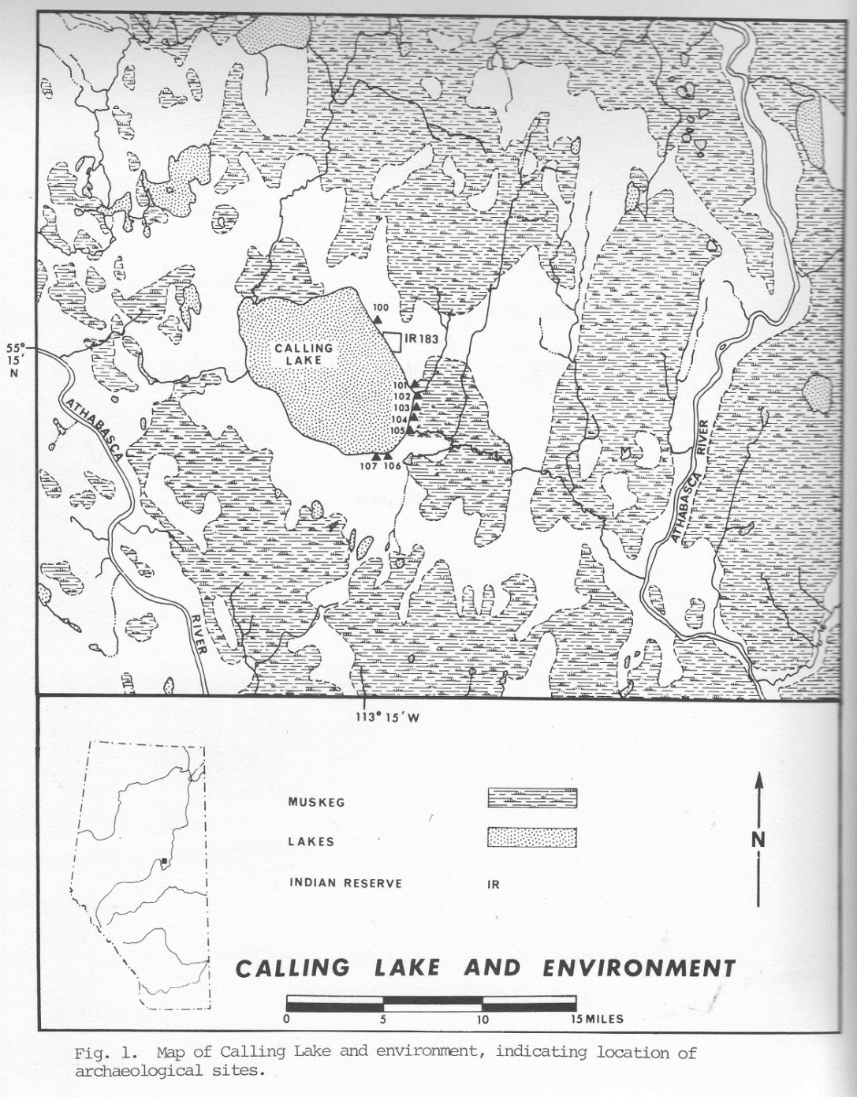
Zierhut, Norman. “Bone-breaking activities of the Calling Lake Cree.” Alberta Anthropologist 1(3):33-36, Edmonton, 1967.
Tables (pp 99-132) Distribution and provenance of findings
Figures (pp 133-184)
- Map of Calling Lake and environment, showing excavation sites – shown here
(p 134)
- Photos and figures of sites, crews at work and artifacts found
(pp 135-184)
- Location of archaeological sites mentioned in the report (p 185)
- List of Mercury series publications
(pp 186-181)

From a description of the work in a U of A Department of Anthropology pamphlet and quoted in By a Lake of Sparkling Blue, page 2:
Until about 10,000 years ago, the Calling Lake area was covered with a thick layer of glacial ice which had come from the northeast. The lake used to be larger than it is now and the old beaches are high above its present shore.
It is probable that the Calling Lake area was occupied continuously by Indian people from the time glacial ice left until historic times; for the remains of their camps, stone flakes and fragments of their tools and weapons are abundant along the east side of the lake. Various groups have come and gone in the area through the centuries. The Indian people now living here are not the direct descendants of the earliest people. Historical records indicate that the Cree spread into this western part of their territory only centuries ago.

