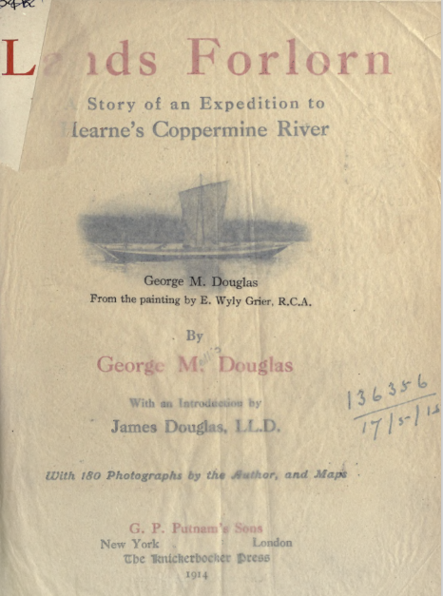
Lands Forlorn
George M. Douglas
Introduction by James Douglas, LL.D.
With 18O photographs by the Author, and Maps
G. P. Putnam's Sons: New York London. Knickerbocker Press, 1914

Account of an “unostentatious expedition” to the Coppermine Mountains “to determine whether there was any analogy between these deposits and those of the Lake Superior district, and to decide whether the prospect was sufficiently promising to warrant investigation on a further and more comprehensive scale. Includes a photo taken at the mouth of the Calling River (page 17) and descriptions of traveling down the Athabasca River.
The book is available online in various formats at https://archive.org.
- Pdf: Lands forlorn : a story of an expedition to Hearne's Coppermine River (archive.org)
- Epub: Lands forlorn : a story of an expedition to Hearne's Coppermine River : Douglas, George Mellis : Free Download, Borrow, and Streaming : Internet Archive
- Full text (without photos and maps):
Lands forlorn : a story of an expedition to Hearne's Coppermine River

Party of three:
August Sandberg,Ph.D., of Sweden; chemist, metallurgist, and geologist. His travels in the remoter parts of Mexico had made him well acquainted with pack animals and life on the trail. He lacked training as a canoeist, but two canoeists were enough in the party and three might have been too many. His wide knowledge, his energy, his modesty, and his conspicuous unselfishness contributed greatly to the success and pleasure of the whole expedition.
Lionel Dale Douglas, Lieut. R.N.R., a Canadian, sailor by profession, and with all the resourcefulness and ability to make the best of things by which sea-going men are justly distinguished. He was well versed in the handling of small craft, a canoeist of exceptional skill, an indefatigable hunter and sure shot with a rifle under all conditions.
George Mellis Douglas, a Canadian by birth, parentage, and early training; an engineer by profession, and by chance more than by any special qualification the leader of the present expedition.
Route: via the Athabasca and Mackenzie rivers, the Bear River, and Great Bear Lake, and thence by the Dease River and the small lakes on the divide to the Coppermine River.
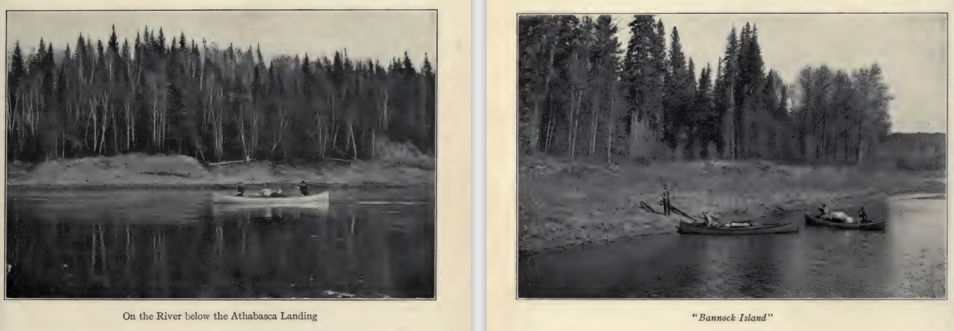
Arrived in Edmonton May 1911, in convoy of wagons two days to Athabasca Landing. From there, started down the Athabasca River
Page 17: Calling River
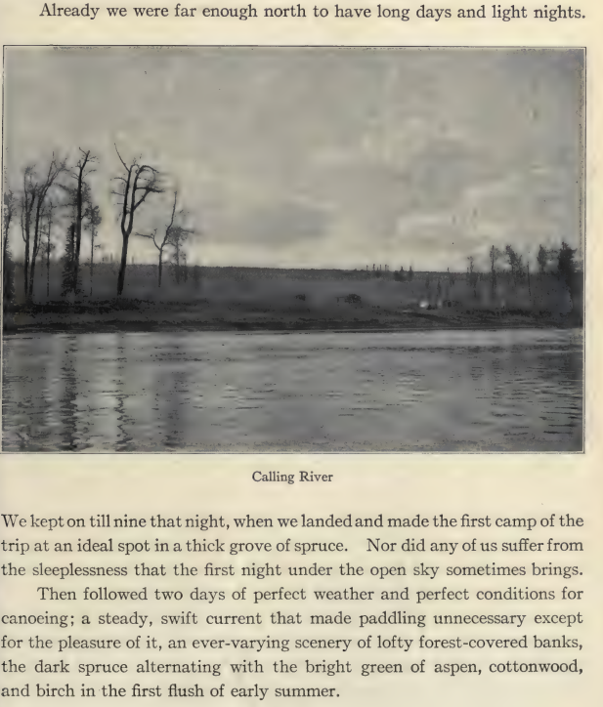

Pelican Portage, page 18:
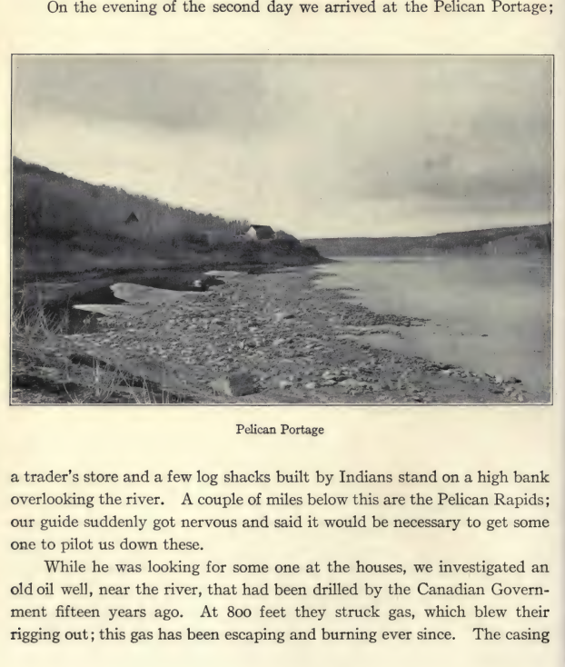

Grand Rapids, Page 19:
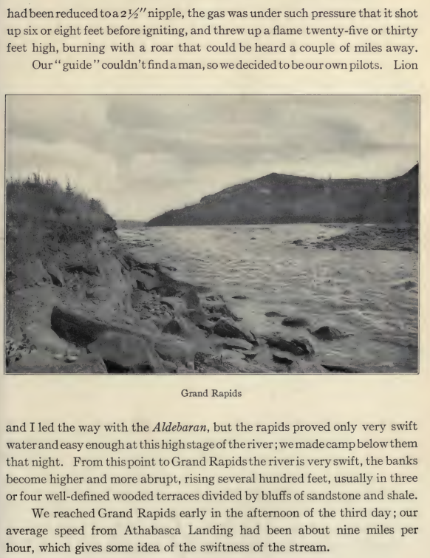

Hudson Bay brigade, Page 20
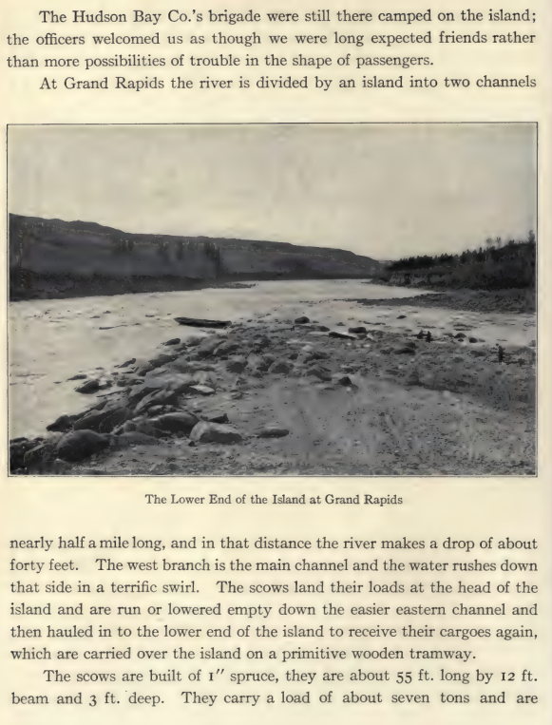

Scow description, page 21
